**Installation Manual**

**Introduction**

This document will explain the steps to install Capture Cart onto your web-browser. Capture Cart is an e-commerce website and for that reason it will require us to use different client side and server side technologies to support the product.

**Server**

The Capture Cart has been test in following server application and has been running it successfully.

|  |  |
| --- | --- |
| **Technology** | **Version** |
| Apache | 2.2.26 |
| PHP | 5.4.25 |
| MYSQL | 5.5. |
| XAMPP PACKAGE | 1.8.2 -6 |

**Client**

This app has been tested on the latest versions of most common browsers in April 2015. However, it might not support some older versions.

|  |  |  |  |
| --- | --- | --- | --- |
| **Browser** | **Version** | **Is it working?** | **Any Comments** |
| Firefox | 31.0 | Yes |  |
| Chrome | 42.0.2311.135 | Yes |  |
| Safari | 7.1 | Yes | Some pages are not being displayed properly |
| Internet Explorer | 11.0.18 | Yes | Some pages are not being displayed properly |

**Installation Process**

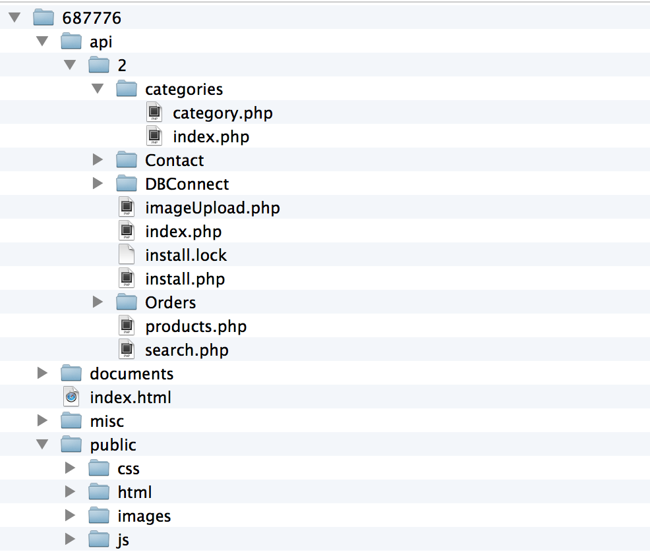This is Folders Layout user should see when the open the folder.

Firstly, you will need to start by copying whole 687776 folder (or extract if zip), into your root folder that you have configured for web server. The most common directory that is also recommended is “htdocs”.

Step 1: In order to install the database just type (**localhost/687776/api/2/install.php**)



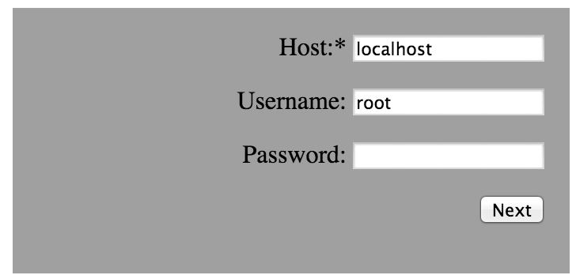

Step 2:

This will install the database and tables into your system and you are ready to go.

Note: In order to re-install the database you must drop your database from phpmyadim and also a file called **install.lock** from localhost/687776/api/2.

**Client**

Just type (**localhost/687776/**), which will take you to client home (index) page and you are ready to go.